1.what is the function of a summation junction of a neuron ? What is threshold activation function ?

Ans : all features are multiplied by their weights and bias are summed up. (Y=W1X1+W2X2+b).Binary Step Activation Function. Binary step function is a threshold-based activation function which means after a certain threshold neuron is activated and below the said threshold neuron is deactivated.

2. What is a step function ? What is the difference of step function with threshold function ?

Ans : step function is a function like that used by the original Perceptron. The output is a certain value, A1 if the input sum is above a certain threshold and A0 if the input sum is below a certain threshold. The values used by the Perceptron were A1 = 1 and A0 = 0

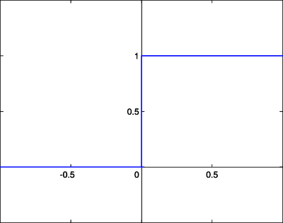

F(x)=1,if X>=0 f(x) = 0,if x < 0

3.Explain the McCulloch-pitts model of neuron.

Ans : The McCulloch-Pitts model was an extremely simple artificial neuron. The inputs could be either a zero or a one. And the output was a zero or a one. And each input could be either excitatory or inhibitory.Here is a graphical representation of the McCulloch-Pitts model

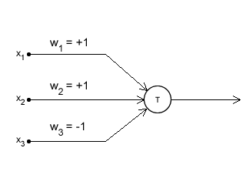

represented things with named variables. The variables w1, w2 and w3 indicate which input is excitatory, and which one is inhibitory. These are called "weights". So, in this model, if a weight is 1, it is an excitatory input. If it is -1, it is an inhibitory input.

x1, x2, and x3 represent the inputs. There could be more (or less) inputs if required. And accordingly, there would be more 'w's to indicate if that particular input is excitatory or inhibitory.sum using the 'x's and 'w's... something like this:

sum = x1w1 + x2w2 + x3w3 + ...

This is what is called a 'weighted sum'.

4.Explain the ADALINE network model.

Ans : ADALINE Network model Known as Adaptive Linear NeuronAdaline is a network with a single linear unit he Adaline network is trained using the delta rule.

MADALINE Many ADALINE is a three-layer input, hidden, output, fully connected, feed-forward artificial neural network architecture for classification that uses ADALINE units in its hidden and output layers.

ADALINE features are..uses bipolar activation function. It uses delta rule for training to minimize the Mean-Squared Error (MSE) between the actual output and the desired/target output. The weights and the bias are adjustable.

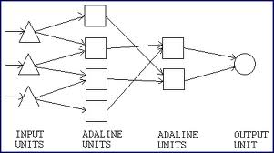

Adaline is a single-unit neuron, which receives input from several units and also from one unit, called bias. An Adeline model consists of trainable weights. The inputs are of two values (+1 or -1) and the weights have signs (positive or negative).

Initially random weights are assigned. The net input calculated is applied to a quantizer transfer function (possibly activation function) that restores the output to +1 or -1. The Adaline model compares the actual output with the target output and with the bias and the adjusts all the weights.

5.what is the constraint of a simple perceptron ? Why it may fail with a real world data set ?

Ans : perceptron is the simplest neural network one that is comprised of just one neuron.the output values of a perceptron can take on only one of two values (0 or 1) because of the hard-limit transfer function

Perceptrons only represent linearly separable problems. They fail to converge if the training examples are not linearly separable.

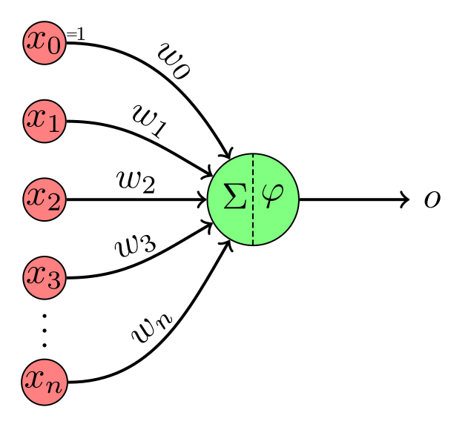

6.what is linearly inseparable problem ?

What is the role of hidden layer ?

Ans : linearly inseparable problem they cannot be solved using a linear decision boundary.one consisting of two sets of points in a 2-d vector space that belong to different classes where the two classes can be separated by a straight line.hidden layer is located between the input and output of the algorithm in which the function applies weights to the inputs and directs them through an activation function as the output.the hidden layers perform nonlinear transformations of the inputs entered into the network.

7.Explain XOR problem in case of a simple perceptron

Ans : The XOR problem is that we need to build a Neural Network a perceptron in our case to produce the truth table related to the XOr logical operator. This is a binary classification problem. supervised learning is a better way to solve it. In this case, we will be using perceptrons. Uni layered perceptrons can only work with linearly separable data. But in the following diagram drawn in accordance with the truth table of the XOR logical operator.

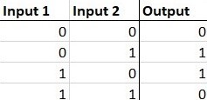

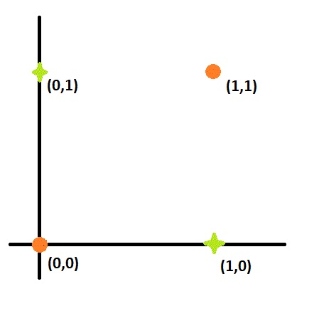

8 Design a multilayer perceptron to implement A XOR B.

Ans : 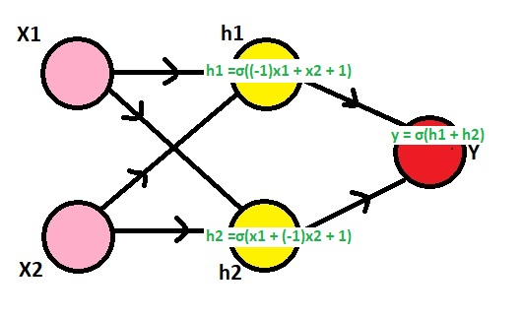

h1 = σ((1-x1) + x2) = σ((-1)x1 + x2 + 1)

h2 = σ(x1 + (1-x2)) = σ(x1 + (-1)x2 + 1)

y = σ(h1 + h2) = σ(h1 + h2 + 0)

9.Explain the single layer feed forward architecture of ANN.

Ans : In this type of network we have only two layers input layer and the output layer but the input layer does not count because no computation is performed in this layer. The output layer is formed when different weights are applied to input nodes.After the neurons collectively give the output layer to compute the output signals.

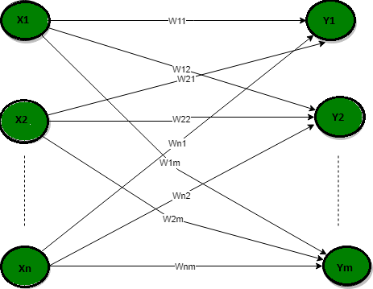

10.Explain the competitive network architecture of ANN.

Ans : competitive network is typically a type of unsupervised machine learning, using the principle of competitive learning to provide results. Through specific mathematical and network modeling, competitive networks achieve various goals in input recognition and processing.

Competitive networks are also known as competitive neural networks.it

consists of a set of hierarchically layered units in which each layer connects, via excitatory connections, with the layer immediately above it, and has inhibitory connections to units in its own layer.

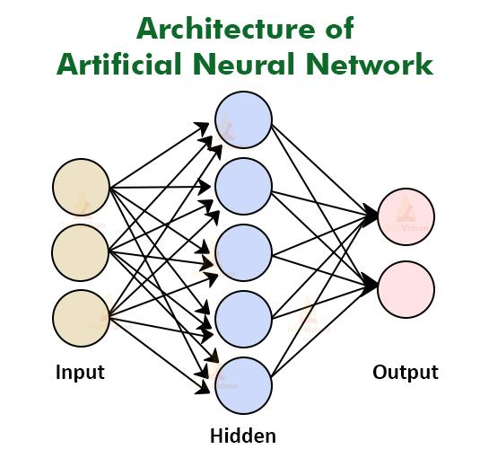

11.consider a multi layer feed forward neural network.enumerate the explain steps in the backpropagation algorithm used to train the network.

Ans : The backpropagation algorithm performs learning on a multilayer feed-forward neural network. It iteratively learns a set of weights for prediction of the class label of tuples. A multilayer feed-forward neural network consists of an input layer, one or more hidden layers, and an output layer.

The Backpropagation algorithm looks for the minimum value of the error function in weight space using a technique called the delta rule or gradient descent. The weights that minimize the error function is then considered to be a solution to the learning problem. Steps:

Step – 1: Forward Propagation

Step – 2: Backward Propagation

Step – 3: Putting all the values together and calculating the updated weight value

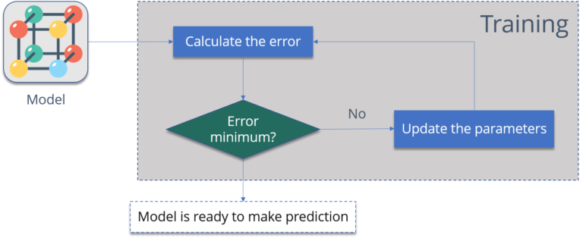

12.what are the advantages and Disadvantages of neural networks ?

Ans : advantages

1.Efficiency 2.Continuous Learning 3.Data retrieval 4.multitasking 5.wide applications

Disadvantages : 1.Hardware dependent

2.Approximate result.3.data dependency

13 write short notes on any two of the following.

1.Biological neuron :

Biological neuron models, also known as a spiking neuron models, are mathematical descriptions of the properties of certain cells in the nervous system that generate sharp electrical potentials across their cell membrane, roughly one millisecond in duration, called action potentials or spikes.

Neurons, also known as nerve cells, send and receive signals from your brain. While neurons have a lot in common with other types of cells, they're structurally and functionally unique. Specialized projections called axons allow neurons to transmit electrical and chemical signals to other cells.

Biological neural networks are known to have such structures as hierarchical networks with feedbacks, neurons, denritic trees and synapses.

2.ReLU Function :

The ReLU function is another non-linear activation function that has gained popularity in the deep learning domain. ReLU stands for Rectified Linear Unit. The main advantage of using the ReLU function over other activation functions is that it does not activate all the neurons at the same time.The rectified linear activation function or ReLU for short is a linear function that will output the input directly if it is positive or it will output zero.

